STRATEGIC BUSINESS INTELLIGENCE IMPLEMENTATION FOR ENHANCED ANALYTICS AT TELCO SOLUTIONS Inc.

**Abstract**

This project was about designing and implementing a scalable and cost-effective Business Intelligence (BI) and Business Analytics system that was developed to meet the ever-changing requirements of a very fast-growing organization in a competitive environment. The project used the most modern platforms like Power BI for analysing and visualization, and Salesforce for customer relationship management, and the main goal of the project was to create a dynamic BI solution that could quickly adapt to the new business requirements, thus enabling stakeholders to make the most impactful decisions through data analytics.

The system's structure included a wide data capture points documentation which was combined with Salesforce to achieve a smooth customer interaction and, thereby, the output from the Power BI analytics was enhanced. This integration caused the development of the interactive dashboards and reports which were the sources of real-time visualizations and the effective predictive analytics, which were essential for the data-driven decision-making processes.

An efficiently designed database, the database being thoroughly thought out with a clear entity-relationship mapping and a complete data dictionary, a coherent structure was established which kept the consistency across the data management practices and it was also closely integrated with Salesforce data structures. Several tests were made using the synthetic data of the actual operational volumes to check the performance and functionality of the system's features in Power BI. These tests were done to make sure the features met the expected outcomes before they were deployed.

The last stage of the implementation process described the system architecture and data managing specifications, in addition to the operational description that was pointing out the system's efficiency and scalability. This project not only achieved its objectives through the teamwork and technical expertise but also set a standard for the future BI projects, which emphasized the transformative power of such systems in the improvement of business operations and decision-making processes, especially when combining the powerful tools like Power BI and Salesforce.

**1. Organization Background**

**Organization Description**

Telco Solutions Incorporated, founded in 2005, started as a small player in the North American telecommunications market, but it has surpassed boundaries to become one of the giants today. Our firm's aim is to undertake the technological aspect of improving connectivity, and ensure that weakened, high speed communication services are in terms of reliability. At present, Telco Telecom Solutions Inc. is enjoying a market share of nearly 15% in the telecoms space. Over 10 million customers are served by the Inc. and more than 5000 employees work with it. Being a midsize player of the industry, the company in consideration inherits its broad network infrastructure and a diverse solution portfolio of communication solutions, specially, mobile, broadband, and fixed line services.



**Market Analysis**

The telecommunications industry is characterized by heavily fighting competitors and marked fast development in technology. The main competitors in this field consist of other national prominent suppliers who compete on pricing, technology, and service level. Telecom Solutions Inc. encounters recurrent concern from the evolution of 5G, IoT and digital streaming services, which enables the whole experience to change and ranks all the sections of the sector. The organization has not only sustained its market standing but also asserted its role by staying on top of innovation, giving adequate attention to customer-centric development, and partnership. Other than AI and machine learning, the integration of these recent technologies is also shaping competitive dynamics whereby Telcos Inc. is now investing in these areas just to stay on par.

**Business Process Scope**

The BI system at Telco Solutions Inc. is targeted to optimize the following key business processes:

Customer Relationship Management (CRM): Data analytics tools to be in play, the company seeks to penetrate richer understanding of customers’ behaviours, keep them loyal, and generate new customer bases. Using sophisticated data analytics, the company will have a possibility to predict customer behaviour and reactions, which will be the base for personalized offers and marketing promotion strategies, to make customers more engaged.

Financial Forecasting: The company can better report income flows, be more resistant to risks, and determine whether capital is to be invested, expenditures are to be reduced, and resources are to be allocated with such processes. The objective of this will be for the strategic planning, health and stability of the company finances and growth.

Supply Chain Operations: BI (Birr. Business intelligence) is believed to be one of the supplying chain management’s tools that can provide data regards to inventory levels, the performance of the suppliers and the logistics efficiencies. It will facilitate smooth operations, lower costs, and ensure efficient delivery among local communities.

This particular documentary illustrates both the good and the bad consequences of this significant change. Its main message is that losing something good and precious can hurt a great deal and that we should never forget this. The output of adoption of the BI has targeted improvement which are better decision making, operations efficiency and customer quality assurance.

**3. System Specification and Design**.

**Data Capture Points**

Telco Solutions Inc. 's BI system turns on a broad spectrum of data associations to have a comprehensive representation of their business operations and customer patterns. It comprises specific information obtained during service processes that include site visits, website experiences, and social media engagements as some of the examples. Transactions data which include information on customer rentals, payments received from customer and terminations, are considered important since these records are analysed to fetch trends and customer life cycles. Besides, the systems get information from external data sources, i.e., the market trends and demographic information, for elevation of analysis level and to remain competitive in the industry of telecommunications.

**Analytics Requirements**

Bi is our system that allows laying down a base for analytics function which include descriptive, predictive and prescriptive modules. Among other things answers operational questions such as service popularity and customer demographics. These features of descriptive analytics provide a present-day business environment with a snapshot. Considering predictive analytics, the recurrent patterns in the past historical data are utilized to forecast events, and churn becomes predictable customer behaviour. Aside from descriptive analytics that uncover the reasons behind the cause and effect, there is also an element called prescriptive analytics which not

only offers strategic actions that can contribute to the desired outcome but also uses optimal customer engagement strategies and resources allocation to achieve them.

**Customer Integration**

Feedback from customers is important at Telco Solutions Inc. The system catches the feedback via real-life interactions with customers’ services and digital interactions and gives the direct instant answer to customers' feelings and needs through this giving the company an affordable way to respond to customer complaints and queries. By making an in-depth journey analysis, businesses obtain intelligence and see the points which are important to customer satisfaction. On the other hand, from the statistical reports of those analyses, the engagement metrics were employed to refine communication strategies by making all interactions that touch on the customer needs and targets.

**Process Flow**

*Fig 1: Process Flow*

This diagram depicts the step-by-step flow of data and operations within the Business Intelligence system introduced at Telco Solutions Inc. The process begins with data aggregation where various datasets are combined into several Excel files. This stage is the most important one as it involves the gathering and initial sorting of raw data into a structured format. After the data collection, the process goes to the Power BI stage, where the datasets are used to make the dashboards that are interactive and provide the insight. Power BI will be a remarkable tool for the data visualization of data trends and analytics, which will help the stakeholders to derive the actionable insights easily. The last phase in the flow is the installation of the CRM (Customer Relationship Management) solution, where the understanding gained from Power BI dashboards is used to improve the customer interactions and service delivery. Thus, this whole-process from beginning to end of data becomes the source of data that both defines business strategies and at the same time, directly improves the operational capabilities of CRM solutions.

**4. Database and Infrastructural Design:**

**Entity-Relationship Diagrams (ERD’s)**

Being the foundation of the BI system of Telco Solutions Inc., they are finely tailored to be pictorially represented through comprehensive Entity-Relationship Diagrams. The given ERD will illustrate the how these data entities i.e. a customer, transaction records, service usage and feedback are interrelated. The ERDs go further than just to demonstrate the relationship between these entities to actually identify a clear route map for the database development to data integration compound. It is paramount, these diagrams be grasped by the development team to avoid any architectural inability of delivering a coherent and efficient database structure.

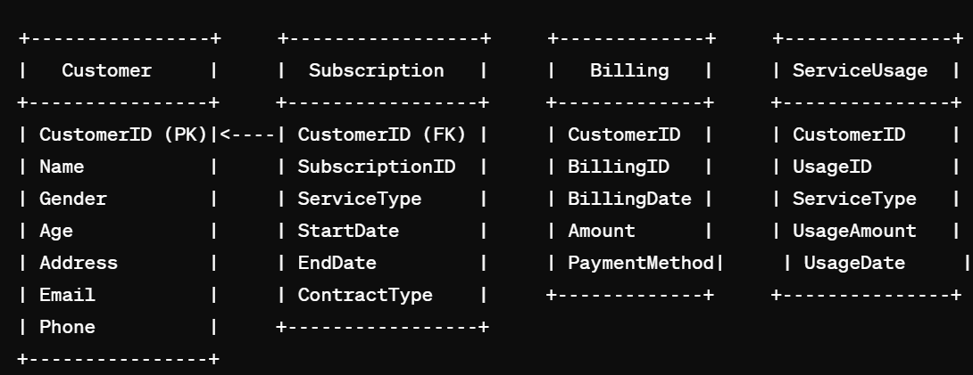

*Fig 2: Entity-Relationship Diagram*

**Data Dictionary**

The system's data dictionary which comes together with ERDs present a comprehensive list of all data structures that make up the complete database. This involves the creation of a highly detailed schema of each table, field, and the relationships between them containing data types and usage notes. The data dictionary is essential for the consistency maintained across the database, and serves as the fundamental resource for developers and analysts; therefore, it guarantees that all members of the team have a unanimous understanding of the database elements and their purposes.

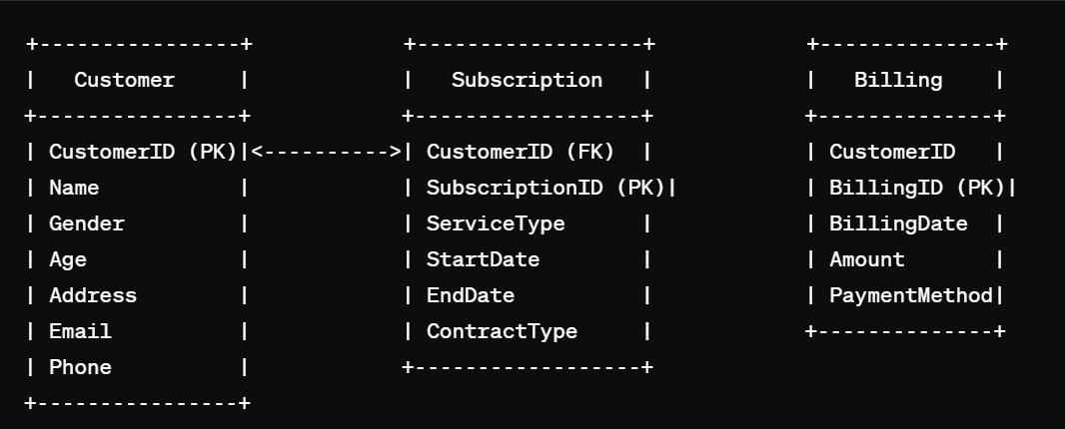

*Fig 3: Data Dictionary*

**System Architecture**

The architecture of the BI system that we are going to implement is divided into three core levels, which are all the supporters of the system performance. At the peak of the pyramid we find Power BI, which we use to create powerful data visualizations and reports that are capable of facilitating users interact with the data and be able to extract insights from it. This level forms the foundation of data-to-information flow as it facilitates the transformation of complex information into useful and actionable insights. The last one is Business Logic Layer that provides functionality by caring the components such as stored procedures, triggers, validation rule, and workflows. These factors thus become crucial as they validate business rules, automate processes and keep the system together through data integrity. The architecture base reinforces the Data Layer, which includes strong SQL database. This section has all the important tables inside such as "Customer", "Subscription", "Billing", "ServiceUsage", and "SupportTicket", which relates one to another with the use of pre-defined foreign key constraints. So these constraints are fundamental for retaining relational integrity across the database, making certain that relationships between data are not disrupted and that the database structure is well-suited to efficient queries process. Each layer, as described above, is illustrated in the System architecture diagram (Figure 3). This helps to depict the system’s structure and how the various components and data entities are interconnected.

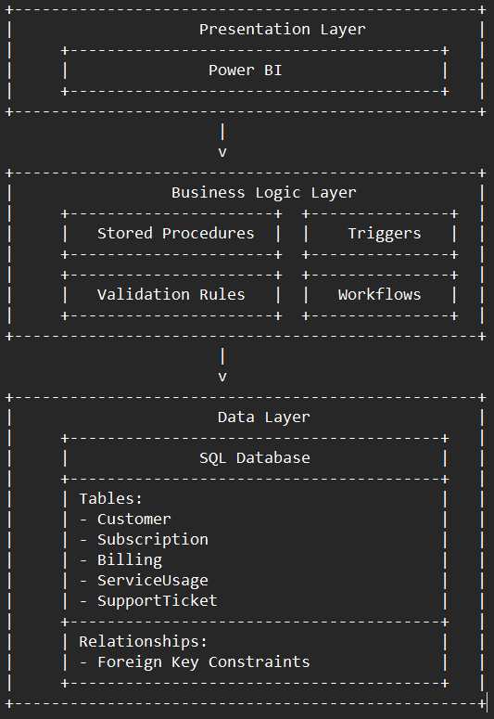

*Fig 4: System Architecture*

**5. Dashboard Development:**

The project consisted of the creation of a number of highly interactive dashboards using Power BI to improve the decision-making at Telco Solutions Inc. The process of development included the extraction and transformation of main datasets, and the design of the visualizations according to the specific business needs.

Churn Rate by Gender Dashboard:

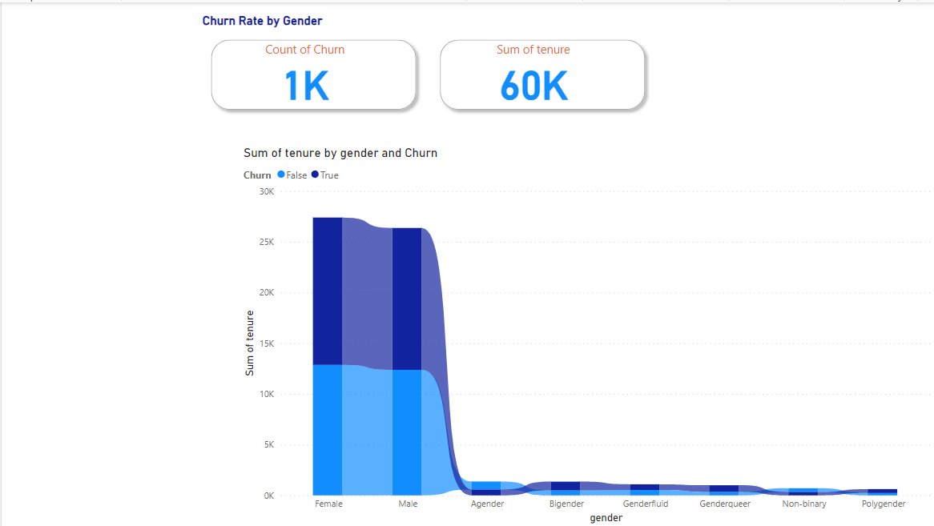

*Fig 5: Churn Rate by Gender Dashboard*

This dashboard illustrates the customer churn rates broken down by gender, hence, it offers the vital information on how the different demographics deal with telco solutions inc's services. By merely looking at the data, stakeholders can see the number of churn events and the total tenure, which are very prominently placed at the top. Under the above indicators, the graph below shows the sum of tenure divided by gender and churn status. The visualization enables the user to see the patterns and trends in customer retention, thus, it is easy to determine which gender, male, female, or non-binary, has higher longevity with the company's service and how their churn rates are similar or different.

The bar graph separates the churned customers (True) and those who have not (False), across different gender identities such as Female, Male, Agender, Bigender, Genderfluid, Genderqueer, Non-Binary, and Polygender. This detailed explanation helps in the understanding of the churn dynamics in each gender group which, in turn, allows customer retention strategies to be tailored based on the quantitative data. The dashboard is vital for the marketing and customer relations teams at Telco Solutions Inc. and it enables data-driven decision-making thus it helps to improve customer satisfaction and to reduce churn.

Customer Risk Analysis Dashboard:

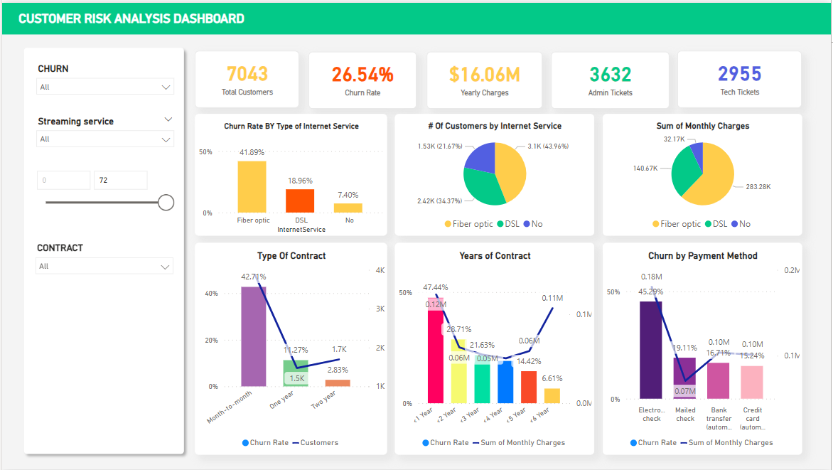

*Fig 6: Customer Risk Analysis*

The "Customer Risk Analysis Dashboard" from Telco Solutions Inc. provides a complete picture of the factors that influence customer churn, combining different data visualizations that give a clear idea of the customer retention problems and opportunities.

Total Customers and Churn Rate: The dashboard neatly shows the total number of customers and the total churn rate, offering a quick overview of the customer retention status and pointing at the immediate need for a strategic intervention.

Churn Rate by Type of Internet Service: This graph shows the churn rates for different internet services like fibre and DSL and identifies the services with higher churn and thus, proposes the improvement areas.

Number of Customers by Internet Service: A pie chart is then given, which shows the division of customers among the various internet services, thereby assisting in the comprehension of market penetration and customer preferences.

Sum of Monthly Charges: This visualization shows the monthly charges by the type of internet service; thus, it helps to identify which services are the major contributors to the revenue, consequently, this would be useful in formulating the pricing and promotional strategies.

Churn by Payment Method: This analysis divides the churn rates by different payment methods and thus provides information about whether the convenience of the payment methods has an influence on loyal customers or no.

Type of Contract: A bar chart depicts the churn rates linked to the different contract types (e. g. contracts, etc). g. These include month-to-month, one-year, two-year, and many more, all offering useful insights on how to manage customer contracts to increase customer retention.

Years of Contract: This line graph shows how the length of contracts is related to the churn rates, so the longer the contracts, the less churn and the higher the customer satisfaction.

Customer Distribution and Revenue Impact: Besides, the extra pie charts divide the number of customers and the total of the monthly charges by the type of the internet service, thereby showing the popularity of the services and their financial impact which are the key aspects for resource allocation and the investment decisions.

Contract Details and Customer Retention: The graphs further elaborate on the contract type and the number of years of the contract against churn, thus, identifying the trends that can be used to come up with the most efficient contract management strategies.

Every part of the "Customer Risk Analysis Dashboard" is so well-designed that it gives the actionable insights to Telco Solutions Inc. that it can make the data-driven decisions to improve the customer service, customise the marketing strategies, and in the end, the churn will be reduced.

Demographic Dashboard:

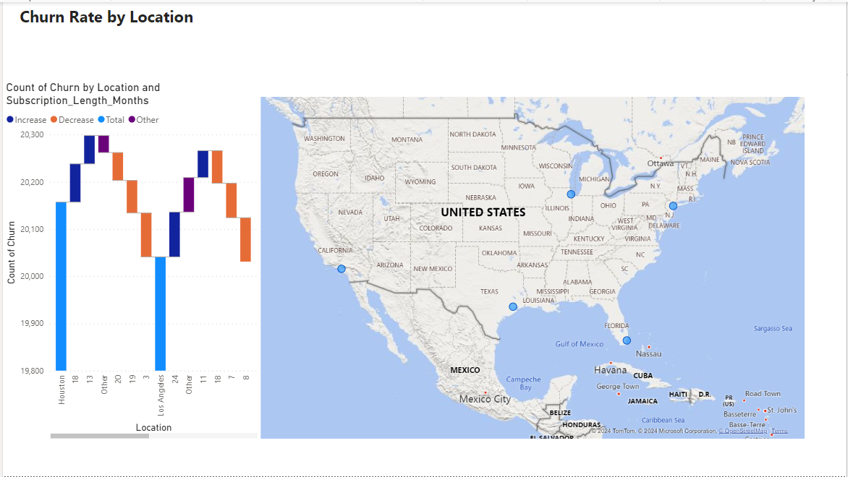

*Fig 7: Demographic Dashboard*

The "Churn Rate by Location" dashboard gives a map of customer churn across the different locations in the United States, and a bar graph showing churn counts by location and subscription length in months. This comparative analysis of the churn rates of the regions and duration of the subscriptions enables Telco Solutions Inc. to visually see and compare the churn rates regionally and to understand the trends over the different subscriptions durations.

Geographic Distribution: The map section of the dashboard shows the regions with the highest customer churn, which are the most troublesome for customer retention. Every single location is indicated on the map, thus giving a clear understanding of the geographical patterns, which may help to construct the regional marketing strategies and to allocate the resources.

Churn Count Analysis: Along with the map, the bar graph classifies churn according to the length of the subscription, and thus highlights the difference of churn rates among short-term and long-term customers in various locations. The bars are color-coded to distinguish between the rises and falls in churn rates, thus giving a quick visual reference to the areas needing immediate action.

This dashboard is a vital component for strategic planning; thus, the company can set up interventions more effectively and get the best out of its efforts to reduce churn in high-risk areas. It not only helps to perceive the spread and density of churn incidents but also links these patterns with the length of the customer engagement, hence aiding in the designing of a more customer retention strategies.

Customer Churn Dashboard:

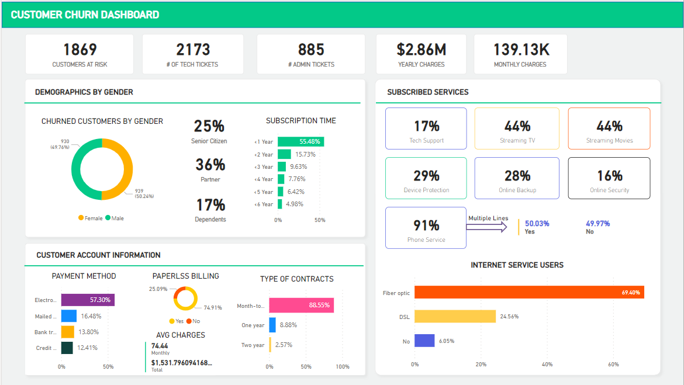

*Fig 8: Customer Churn*

Customer Churn Dashboard Overview

The "Customer Churn Dashboard" at Telco Solutions Inc. is a multi-faceted tool that presents the customer retention metrics, which in turn, gives important information on the different factors that are the cause of the customer loyalty. This dashboard combines several data points to provide an all-round picture of churn dynamics and customer demographics.

Customers at Risk and Tech Tickets: The dashboard first points out 'Customers at Risk', meaning the number of customers that are probably to churn, and also the count of 'Tech Tickets', which is the measure of the technical problems that are reported. These metrics are indispensable for the taking of prompt actions to avoid the churn.

Demographics by Gender: A pie chart depicts the churned customers by gender, which in turn allows a demographic analysis of churn trends and thus, the gender specific retention strategies can be designed.

Churned Customers by Gender: This part has a graphical illustration of churn distribution between male and female customers; thus, it gives a glimpse into the gender that needs more focused communication and retention strategies.

Subscription Time: The customer breakdown by subscription length is a typical way to understand the retention rates and the critical periods where customers are more likely to churn.

Subscribed Services: Shows the percentage of customers that have opted in to certain services like Tech Support, Device Protection, etc. and is thus used to identify popular services and to develop strategies to reduce churn.

Customer Account Information: The sentence covers the data on the payment methods, paperless billing status, and the average charges which are the factors that make the analysis of payment trends and their association with churn rates possible.

Type of Contracts and Internet Service Users: Bar graphs present the categories of contracts customers have and the division of internet service users by type (Fiber optic, DSL) thus, they are able to get a better insight on the customer's preferences and loyalty.

Every component of this dashboard is meant to give actionable insights, and with this, Telco Solutions Inc. can put in place the exact, data-driven strategies for customer retention and churn reduction in different customer segments.

Churn Support Dashboard:

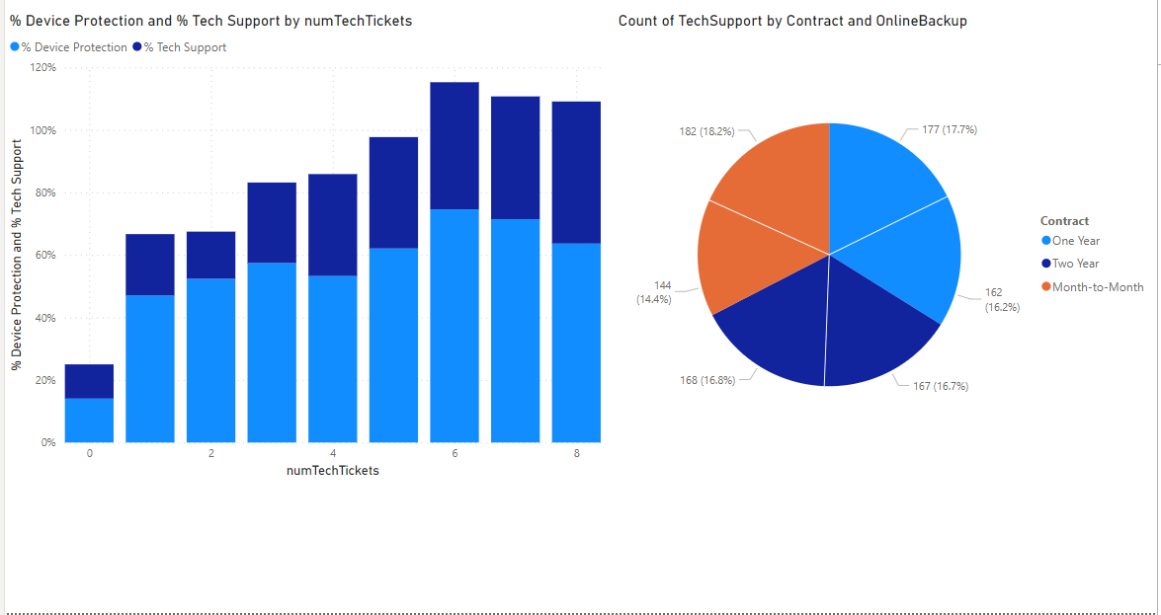

*Fig 9: Churn Support Dashboard*

The "Customer Support Dashboard" of Telco Solutions Inc. gives a clear visualization of the technical support dynamics and device protection utilization among customers, which is divided by the number of technical support tickets.

Percentage of Device Protection and Tech Support by Number of Tech Tickets: This bar chart shows the connection between the number of technical support tickets issued and the percentage of customers who have selected the device protection service against those who have got tech support. The graph shows that, the more the number of tech tickets rises, the greater the proportion of customers have device protection, hence the correlation between the higher engagement with technical support service and the probability of having device protection plans.

Count of Tech Support by Contract Type and Online Backup: The pie chart next to shows the way the tech support tickets were divided across the different contract types, with the contracts being Month-to-Month, One-Year, and Two-Year. This graphical illustration is the key in the analysis of the contract types that lead to more technical support needs and the role of the services like online backup in the increase of tech support inquiries. The part of the pie chart that is dedicated to each contract type shows the percentage of total tech support interactions that are related to that contract type, thus, it gives information about the customer behaviour and service utilization patterns.

This dashboard at the same time also helps in the monitoring and analysis of the efficacy of customer support services and the identification of possible areas to improve the support strategies and contract management at Telco Solutions Inc.

1. **CRM Integration for Telco Solutions Inc.**

The combination of an effective Customer Relationship Management (CRM) system with the Business Intelligence (BI) infrastructure of Telco Solutions Inc. has been crucial in the improvement of customer interaction and service delivery. This document presents the strategic achievement and the advantages noticed from the salesforce CRM integration into our data analytics framework, mainly due to the Power BI visualizations.

The primary objectives for integrating CRM into Telco Solutions Inc. ’s operations were to:

1.Boost customer interaction and happiness

2.Through real-time tracking of customer behaviors and preferences, companies can get instant insights into their processes and customers.

3.The data-driven decision-making system is the tool which will be used in order to improve the business operation.

**System Implementation:**

The integration involved several key steps to ensure seamless data flow between Salesforce CRM and Power BI.

1. Data Aggregation: The data of customers is gathered from various sources which are service interactions, social media, and transactional records.

2.Data Visualization: The use of Power BI for designing interactive dashboards that show customer data visually to enable better insights and decision-making.

3.CRM Deployment: By using Salesforce CRM, the feedback from Power BI can be used for enhancing the customer's interaction and service delivery.

**Key Dashboards and Metrics:**

Below are some of the crucial dashboards and metrics developed to monitor and improve customer-related KPIs:

1.**FYTD Revenue**

* The FYTD closed gauge chart revealing the FISCAL YEAR TO DATE (FYTD) closed won opportunities, which indicates €314k (10%) against the target.

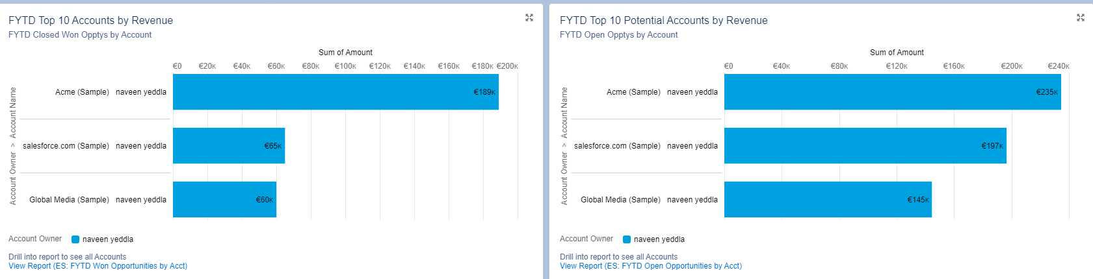

* Besides, visualization of revenue by quarter and month was a method to monitor performance over time.
* The ability to drill-down into the closed opportunities for a detailed analysis is the option A.

**2.Opportunity Pipeline**

* Funnel chart illustrates the stages of opportunity from qualification to negotiation, totaling to €576k.
* The analysis of the sales data provides insights into the areas where opportunities are and, at the same time, it helps in the prediction of the future revenues.

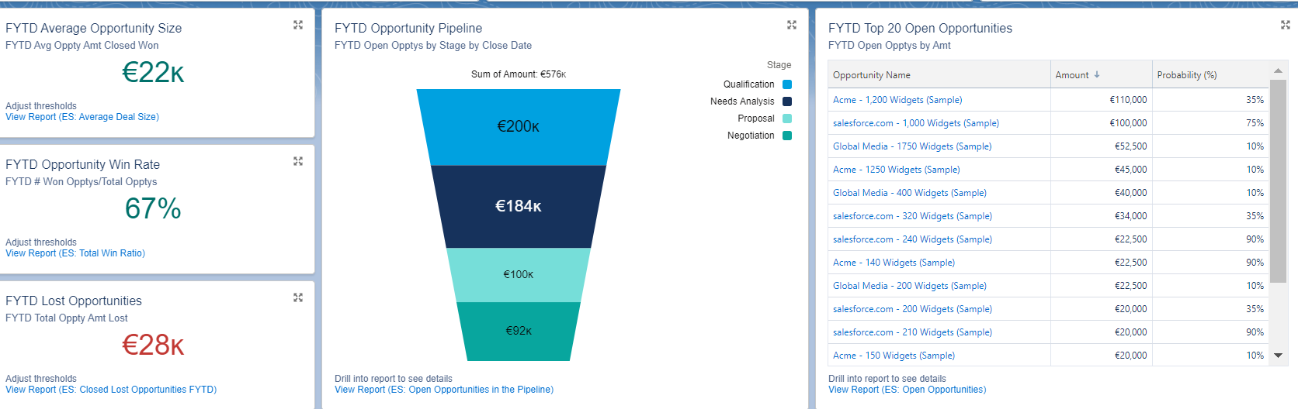

**3.Top Accounts and Opportunities:**

Bar graphs showcasing the top 10 accounts by revenue and the top 20 open opportunities by amount.

This way, it is possible to concentrate on high-value accounts and thus to maximize the revenue potential.

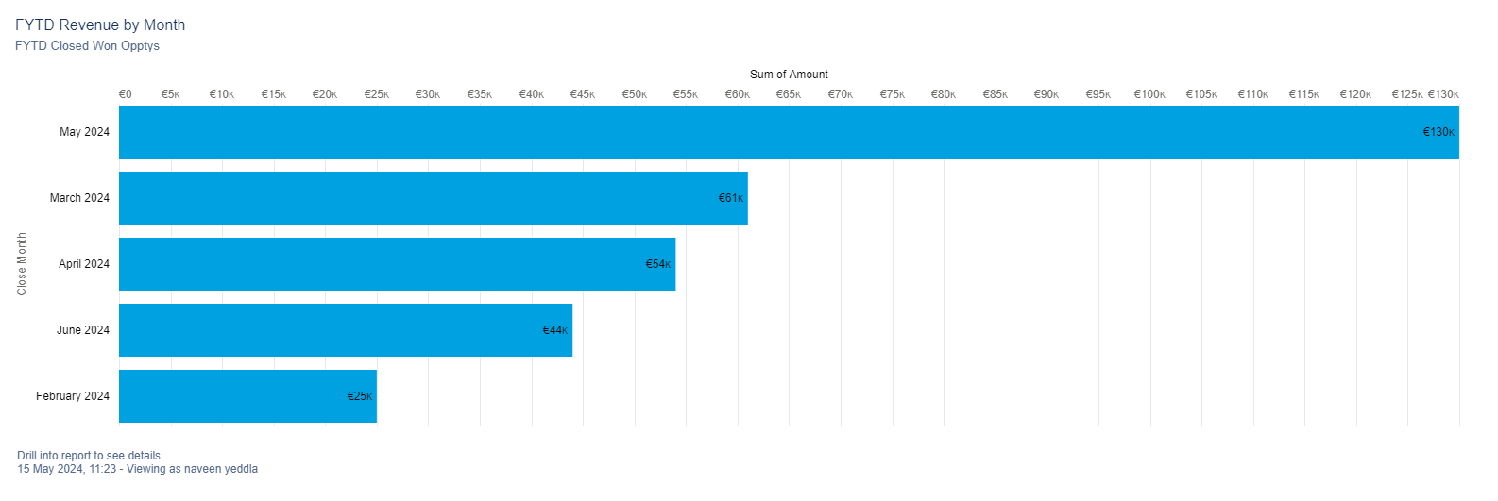

**4.The mean Average Opportunity Size**

* Win Rate are the statistics that depict the typical value of each case and the likelihood of winning respectively.
* Metrics show that the average opportunity size is €22k and the win rate is 67%.
* Assists in the comprehension of the usual deal size and success rate, thus, of setting the true sales goals.

**5.Lost Opportunities**

* The research of the overall amount of the closed-lost opportunities, which sums up to €28k, is given.
* Identifies the areas for improvement in the sales process in order to avert future losses.

**6.The customer Risk and Support Analysis**

* Comprehensive view of customer risk factors, technical support tickets, and device protection plans.
* It gives us the actual advice on how to improve the customer support and decrease the churn.

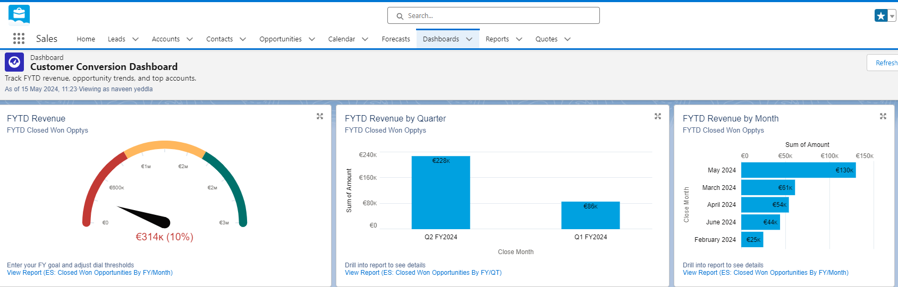

**Benefits Realized**

* Enhanced Decision-Making: The real-time data visualization and analytics have facilitated the making of more informed decisions which in turn have led to strategic business moves.
* Improved Customer Engagement: CRM data has given us the ability to make personalized customer communication and more efficient service.
* Increased Revenue: Targeted on the high-value opportunities and accounts has led to the increase of revenue and the sales performance has improved.
* Operational Efficiency: The smoothening of processes and the improved integration of data has resulted in an increase in the efficiency of the customer relationships and the internal operations.

Through the integration of Salesforce CRM with Power BI, Telco Solutions Inc. has built a comprehensive and dynamic BI system that ensures the better customer relationship management and the business growth through data-driven insights.

**8. Implementation and Deployment**

**Deployment Strategy**

The installation of the BI system at Telco Solutions Inc. was carried out in a step-by-step way to make sure that there was no interruption to the work that was ongoing while at the same time, the new system was made as efficient and as effective as possible.

- Pre-deployment Preparation: This phase was about the organization being ready for the new system. The project entailed finalizing all the system configurations, providing staff training and establishing the support structures to ease the transition.

- Pilot Testing: The BI system was first implemented in a controlled environment within some selected departments, and only then it was fully deployed. This pilot phase gave way to the actual testing of the system’s performance and the possibility of making the required modifications according to the feedback.

- Phased Rollout: After the successful tests the system was rolled out in the organization in phases. Every phase was aimed at particular departments or geographic areas and thus, the IT staff was able to handle the implementation in a special way and to resolve any problems as they came to be.

- Final Cutover: After the successful implementation in all phases, the last switch-over was the one that involved the whole transition to the new BI system. Full checks were carried out to confirm that all information and processes were accurately transferred.

**Final Architecture**

The last structure of the BI system at Telco Solutions Inc. was created to be robust, scalable, and fully compatible with the current IT infrastructure.

- Data Integration Layer: The main feature of this essential element was that it facilitated the integration of data from different sources, including the legacy systems, into the BI platform. The data integration layer that was made up of ETL (Extract, Transform, Load) processes had the data that was consolidated into a structured format suitable for analysis.

- Centralized Data Warehouse: The central data warehouse, which was the main component of the BI architecture, was the place where all the organizational data was stored in one big repository. This plan led to the easier management and the more secure data.

- Analytical Processing Tools: The analytical tools that were integrated in the system gave the processing power to process the complex queries and come up with the insights in a short period. These tools were the backbone of both the descriptive and the predictive analytics, hence, they made it possible to carry out deep data analysis and, in the future, to forecast the trends.

- Presentation and Reporting Layer: The super-structure of the architecture comprised of many reporting and visualization tools, for instance, Power BI. This layer helped the end-users to see the tailored reports and the dynamic dashboards, which gave them the insights that were easy to understand and could be used by different levels of the organization.

- Security and Compliance Measures: Starting from the architecture, the security protocols and the compliance measures were put in place. The main points were data encryption, user authentication, and the audit trails that would guarantee the integrity of data and meet the regulatory requirements.

Through the BI system implementation at Telco Solutions Inc. the organization was able to change the way of the data handling and analysis. The gradual method reduced the dangers, and at the same time, the strong architecture made sure that the system was fully connected and ready to handle the present and the future requirements.

**Conclusion**

The strategic focus on the entire Business Intelligence (BI) system at Telco Solutions Inc. which is linked with Salesforce Customer Relationship Management (CRM), has been a key step in our journey to data-driven decision making and customer engagement. This project has proven that the modern BI tools and CRM systems have the capacity to change the way of doing the things and thus can be used to achieve the operational excellence and business growth.

The fusion of Power BI and Salesforce has given Telco Solutions Inc. the ability to detect real-time, actionable information on different fields of our business, for example, revenue tracking, opportunity management, and customer support. The interactive dashboards that have been created during the project are currently being used by stakeholders to view the key metrics, detect the trends and make decisions that are in line with our strategic objectives.

**Key achievements of this implementation include:**

1. Enhanced Customer Understanding: Through the use of advanced data analysis, we have been able to get into the customer behaviors and preferences which will help us to build personalized interactions and thereby increase customer satisfaction.
2. Improved Revenue Tracking and Forecasting: The skill of keeping an eye on fiscal year-to-date (FYTD) revenue, the analysis of opportunities, and the prediction of potential income have made it possible to have more precise financial planning and the allocation of resources.
3. Optimized Sales Processes: The thorough investigation of the opportunity pipeline, win rates, and average deal sizes has brought us the information that is useful for the reformation of the sales strategies and the emphasis on the high-value opportunities.
4. Increased Operational Efficiency: The data integration from different touchpoints and the reduction of the process to a single stream have led to better customer relationship management and support services.

To sum up, the efficient and smooth running of the BI and CRM system proves Telco Solutions Inc 's dedication to the innovation and excellence. The system satisfies our current business needs and at the same time, it is the one which can be scaled up and can accommodate future requirements. As we go on in a competitive telecommunications environment, this reliable data analysis system will still be a pillar of our strategy, thus making the business to grow and the customers to be satisfied.

The lessons gained and the standards that have been established by this project are a guideline for the future BI projects and prove that data integration and visualization are of great importance in the winning of the business. Telco Solutions Inc. is now more capable of coping with the challenges of the market, getting the biggest opportunities, and staying as a major player in the telecommunications industry.

**Links of MIRO and TRELLO:**

1. **<https://miro.com/welcomeonboard/OUNxdDBNaktrbFJrakhxdjFER2RVa3htUW85Ynhzd0lPOW1yZGptaDNScXZQdzRlR0N1MWxrV3BJSlBYWnJUZXwzNDU4NzY0NTgyMjE1NTQwOTMxfDI=?share_link_id=909646751126>**
2. **https://trello.com/b/mkixfaS1/biba-project**